BLOGPOST - Making Sense of MVP

Making sense of MVP (Minimum Viable Product)
Video: https://www.youtube.com/watch?v=0P7nCmln7PM

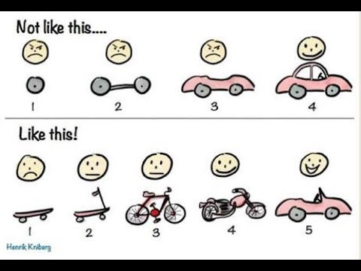

Description
Adapted from Crisp's blog by Henrik Kniberg. Explaining his MVP drawing. This drawing shows up all over the place, in articles and presentations, even in a book (Jeff Patton’s “User Story Mapping” – an excellent read by the way). Many tell me the drawing really captures the essence of iterative & incremental development, lean startup, MVP (minimum viable product), and what not. However, some misinterpret it, which is quite natural when you take a picture out of it’s original context. Some criticize it for oversimplifying things, which is true. The picture is a metaphor.

Find the original article here: http://blog.crisp.se/2016/01/25/henri...

Video by The CRM Team. For more great content have a look at our resources page here: http://thecrmteam.com/resources/

Aus <https://www.youtube.com/watch?v=0P7nCmln7PM>

